'''

Mr Somanath is a math teacher. He is given a problem to his students.

The students are given a number N, and the student has to perform following step:

- Add each digit of the number and add the result to N

Repeat this procedure until N becomes a single digit number.

Your task is to help the students to perform the above steps and

print the resultant single digit number N.

Input Format:

-------------

An integer, number N.

Output Format:

--------------

Print an integer result.

Sample Input-1:

---------------

95

Sample Output-1:

----------------

5

Explanation:

------------

95 => 9 + 5 = 14

14 => 1 + 4 = 5

Answer is 5

Sample Input-2:

---------------

765

Sample Output-2:

----------------

9

'''

n=int(input())

# r=0

# sum=0

def nums(n):

if n%10 ==n :

return n;

else:

sum=0

r=0

while n>0:

r=n%10

sum=sum+r

n=n//10

return nums(sum)

print(nums(n))

You are given two integers M and N,

You need to find the count of bits different in

their binary representation.

For example:

---------------

M = 4 and N =6

Binary of 4 => 1 0 0

Binary of 6 => 1 1 0

Count of bits different are 1.

Input Format:

-------------

Two integers M and N

Output Format:

--------------

Print an integer, count of bits different

Sample Input-1:

---------------

1 4

Sample Output-1:

----------------

2

Explanation:

------------

1 -> 0 0 1

4 -> 1 0 0

d s d

d-> different

s-> same

Now, count of d's is the answer.

My soln:

import java.util.*;

public class Main{

public static int bin(StringBuffer s1,StringBuffer s2){

int n1=s1.length();

int n2=s2.length();

int count=0;

if(n1>n2){

for(int i=n1-n2;i<n1;i++){

s2.insert(0,"0");

}

}

else if(n2>n1){

for(int i=0;i<n2-n1;i++){

s1.insert(0,"0");

}

}

for(int i=0;i<s1.length();i++){

if(s1.charAt(i)!=s2.charAt(i)){

count+=1;

}

}

return count;

}

public static void main(String[] args){

Scanner sc=new Scanner(System.in);

int n1=sc.nextInt();

int n2=sc.nextInt();

String s11=Integer.toBinaryString(n1);

StringBuffer s1=new StringBuffer(s11);

String s22=Integer.toBinaryString(n2);

StringBuffer s2=new StringBuffer(s22);

System.out.println(bin(s1,s2));

}

}

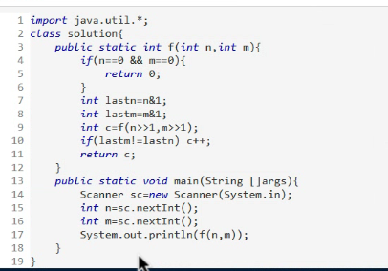

ABC company is transmitting its binary data to another server. To secure

the data against malicious activity, they plan to encrpt the data by

switching 0's to 1's and 1's to 0's.

Return the encrypted data in decimal representation.

Input Format:

-------------

An integer, represents the decimal form of binary data..

Output Format:

--------------

Print an integer result.

Sample Input-1:

---------------

12

Sample Output-1:

----------------

3

Explanation:

------------

12= 1010 will become 0101=3

Sample Input-2:

---------------

23

Sample Output-2:

----------------

8

Explanation:

------------

23= 10111 will become 01000=8

My soln

import java.util.*;

public class Main{

public static int bin(StringBuilder s){

// System.out.println(s);

for(int i=0;i<s.length();i++){

if(s.charAt(i)=='0'){

// s.replace(i,i,"1");

s.setCharAt(i,'1');

}

else{

// s.replace(i,i,"0");

s.setCharAt(i,'0');

}

}

String s1=s.toString();

// System.out.println(s);

int n=Integer.parseInt(s1);

int sss=Integer.parseInt(s1,2);

// System.out.println(sss);

int sum=0;

return sss;

}

public static void main(String[] args){

Scanner sc=new Scanner(System.in);

int n=sc.nextInt();

String ss=Integer.toBinaryString(n);

StringBuilder s=new StringBuilder(ss);

System.out.println(bin(s));

}

}